Title:
Applications of the new fs-laser capability in tri-beam for large volume microscopy

Authors:
A. Gholinia, J. Donoghue, M. Curd, P.J. Withers, and T. L. Burnett
Henry Royce Institute and Department of Materials, The University of Manchester, Manchester, M13 9PL, UK

Summary:
Here we outline a triple beam microscope, which uses the new capability of an in-situ fs-laser coupled with Xe+ PFIB and electron beam. This has evolved from the more traditional Ga FIB-electron dual-beam and ex-situ laser systems. It is capable of large scale volume milling, mini test piece manufacture, serial section tomography and TEM preparation. We have studied a wide variety of materials, where we are investigating different applications including metallic, ceramics, mixed phase materials. In all cases the triple beam system shows itself to be capable of probing large (mm) volumes to collect low damage 2D and 3D images.
Key words: 3D EBSD, fs-laser, large volume serial section technique
Introduction:
The ultra-short pulse with femtosecond (fs)-laser has enabled rapid and large volume excavation of material without sample heating and minimal damage compared to nano-second and pico-second lasers in the past. The control of surface damage is necessary for successful electron microscopy applications, which is much more critical than the more conventional uses of laser ablation for the sole purpose of macro-machining and laser assisted additive manufacturing.
The use of fs-laser for electron microscopy application was first implemented at University of California, Santa Barbara [1], where a fs-laser beam was coupled into a dual-beam focused Gallium ion beam (FIB) and scanning electron microscope (SEM) to form a tri-beam geometry. It is only very recently that commercial tri-beam systems have become available, where the in-situ fs-laser in a dual beam can be used for multi-purpose applications, including serial section tomography (SST) and rapid micromachining [2]. The use of Plasma-FIB (PFIB) instead of Gallium-FIB gives the added capability to more rapidly polish fs-laser prepared surfaces.

Methods/Materials:
The system consists of fs-laser coupled to a traditional dual beam chamber by Thermo Scientific, where Xenon-PFIB is at 52° and the electron beam is vertical at 0° to surface normal to a horizontal specimen. The fs-laser is mounted on the opposite side to the PFIB at an angle of 60°, where all the beams are aligned to coincident at the eucentric height, as shown in figure 1. The system is equipped with the latest electron backscatter detector (EBSD) with complementary metal oxide semiconductor (CMOS) image sensor and energy dispersive detector (EDS) silicon drift (SD) technologies from Oxford Instruments plc.

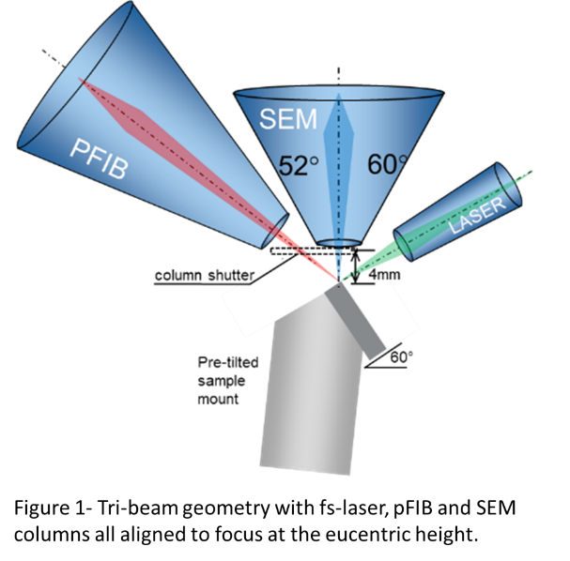
Results and Discussion:
Here we will exploit one of the first such systems to show a variety of materials and applications from surface polish of multi-phase materials, and serial sectioning to large area transmission Kikuchi diffraction (TKD) methods. We will discuss how this capability can bridge the gap for correlative methodologies for connecting large volume electron microscopy with X-ray computed tomography (CT). It allows for much richer large volume datasets by complementing 3D micro-structural information with 3D local crystal structure analysis (texture, morphology and misorientation, etc) by EBSD and chemical compositions by EDS to create massive multi-dimensional datasets. For a very wide range of sample types, it enables the routine collection of volumes 1000 times larger than compared to conventional SST, FIB and broad ion beam (BIB) based techniques [3, 4] under comparable timescales, see figure 2, which is adapted from [5].
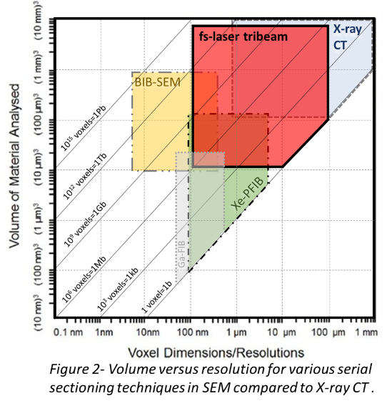
High power fs-laser ablation allows rapid large volume removal or excavation in high resolution for electron microscopy applications. This is highly desirable for analysis of relatively large volumes in reasonable time and increase the statistical analysis of the data compared to conventional FIB techniques. The quality of the surface produced after high power fs-laser ablation is material dependant, but laser induced periodic structures (LIPSS) formation can introduce nanoscale surface topography. However it is surprising that despite the rippled surface features caused by the LIPSS the near surface quality is pristine. In fact, it is possible to get EBSD signal from crystalline materials, at suitable positions that the shadowing caused by the LIPSS features, to the EBSD detector, is minimised. There are reports that have claimed the LIPSS free surfaces can be polished with fs-laser, by reducing the pulses per spot [6]. The reason for this is not clear and is highly materials dependant, which we have discussed more in depth in our paper [7].
As an early adopter we will show case unrivalled multidimensional information about new materials systems and devices. We will demonstrate by analysing materials systems for next generation battery systems to biological tissues.
Conclusions:
The fs-laser technology allows for rapid ablation without heating the sample, which is essential to obtain very low damage surface suitable for high resolution electron microscopy studies. The tri-beam system represents clear step forward from the existing Ga-FIB and PFIB system used for SST. It enables the 2D and 3D microstructural analysis of a diverse range of materials. The addition of fs-laser brings it’s own advantages, for example the ability to work with non-charged particles and minimise damage and reaction with the sample. However it also has challenges, such as surface roughness caused by LIPSS, which the tri-beam allows, through the use of the PFIB, to overcome these.

References:
[1] M.P. Echlin, M. Straw, S. Randolph, J. Filevich, T.M. Pollock, The TriBeam system: Femtosecond laser ablation in situ SEM, Materials characterization, 100 (2015) 1-12.
[2] S.J. Randolph, J. Filevich, A. Botman, R. Gannon, C. Rue, M. Straw, Femtosecond pulse laser ablation for large volume 3D analysis in scanning electron microscope systems, Journal of Vacuum Science & Technology B, 36 (2018).
[3] A. Gholinia, M.E. Curd, E. Bousser, K. Taylor, T. Hosman, S. Coyle, M.H. Shearer, J. Hunt, P.J. Withers, Coupled Broad Ion Beam-Scanning Electron Microscopy (BIB-SEM) for polishing and three dimensional (3D) serial section tomography (SST), Ultramicroscopy, 214 (2020).
[4] T.L. Burnett, R. Kelley, B. Winiarski, L. Contreras, M. Daly, A. Gholinia, M.G. Burke, P.J. Withers, Large volume serial section tomography by Xe Plasma FIB dual beam microscopy, Ultramicroscopy, 161 (2016) 119-129.
[5] M.P. Echlin, T.L. Burnett, A.T. Polonsky, T.M. Pollock, P.J. Withers, Serial sectioning in the SEM for three dimensional materials science, Current Opinion in Solid State & Materials Science, 24 (2020).
[6] A. Jelinek, M.J. Pfeifenberger, R. Pippan, D. Kiener, A Perspective to Control Laser-Induced Periodic Surface Structure Formation at Glancing-Incident Femtosecond Laser-Processed Surfaces, JOM, 73 (2021) 4248-4257.
[7] A. Gholinia, J. Donoghue, M. Curd, M. Lawson, B. Winiarski, R. O’Sullivan, P.J. Withers, T.L. Burnett, Application and capabilities of fs-laser tri-beam microscopy, TBC, (2023).

